Institute Cultural Event Management
Software Requirements Specification



Submitted By
Harshit Singh (B15CS019)
Nikhil Bhamare (B15CS019)

Revision History
Date | Version | Description | People
12 Jan 2017 | 1.0 | First draft | Project Group:
Harshit Singh
Nikhil Bhamare
1 Feb 2017 | 2.0 | Beta version | Harshit Singh  Nikhil Bhamare

Table of Contents
1. Introduction 4
1.1 Purpose 4
1.2 Scope 4
1.3 Constraints 4
1.4 Assumptions and Dependencies 4
1.5 Definitions, Acronyms and Abbreviations 4
1.6 Organization of the Document 4
2. Overall Description 4
2.1 Product Functions 4
2.2 User Characteristics 5

Software Requirements Specification

Introduction

Purpose
The purpose of this document is to give the requirement specifications of the software which aims to facilitate the organization and management of annual cultural event.

Scope
The software will provide a platform for the participants to view and register for cultural events. The software will also give a schedule of the various activities to be held in the event.

Constraints
The following are the given constraints:-
a. Time (duration of event)
b. Space (Number of rooms and stage available)
c. All the details given by the participants while registering are true.

Assumptions and Dependencies
The assumptions are as follows:-
a. Assuming the event will last for 4 days b. Assuming 3 stage areas are available
c. Assuming that the user have a computer and Internet connection.

Definitions, Acronyms and Abbreviations
Term | Definition
SRS | Software Requirement Specifications

Organization of the Document
The remaining sections of this document provide a general description, including characteristics of the users of this project, the functional and non functional requirements of the software. General description of the project is discussed in section 2 of this document. It also gives the user viewpoint of product.

Overall Description

Product Functions

Functional Requirements
The functional requirements of the software are as follows:-
- A user interface-
Which gives a platform for the administrator (organizer) to display the basic and important information regarding the event which shall include the activities and competitions to be held, the pronites to be held, contact persons with their phone numbers and material relevant to the event. This interface also allows the participants to view this information. This interface will also allow the user(participants) to be able to register for the events.
- A feature to login into the system-
Once a participant has registered for an event he/she should be able to login into the system where he/she can see the events he/she have registered for along with the date, time and venue.
This shall include the authentication of username and password.
- Display a proper schedule of the events without the clash of events(activities and competitions) due to same slot

2.1.1 Use Case Diagram

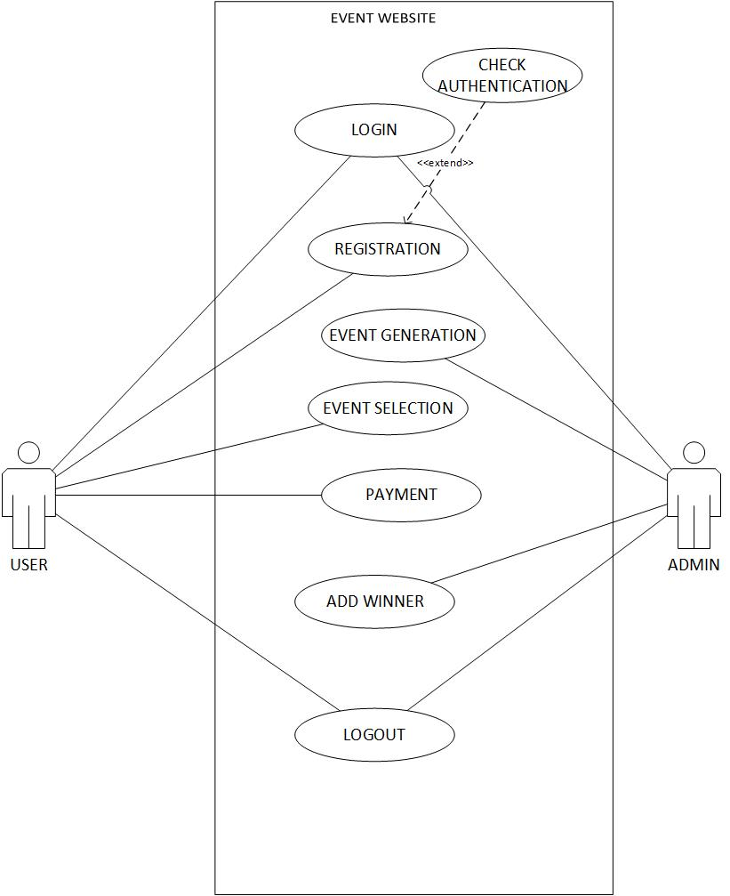

Class Diagram
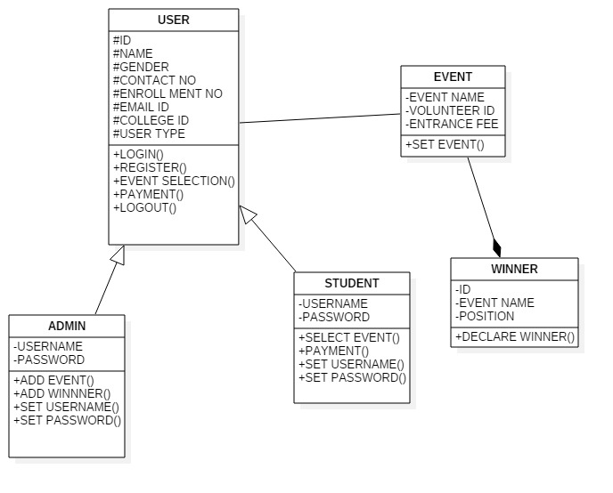

.2.1.1.3 Sequence Diagram
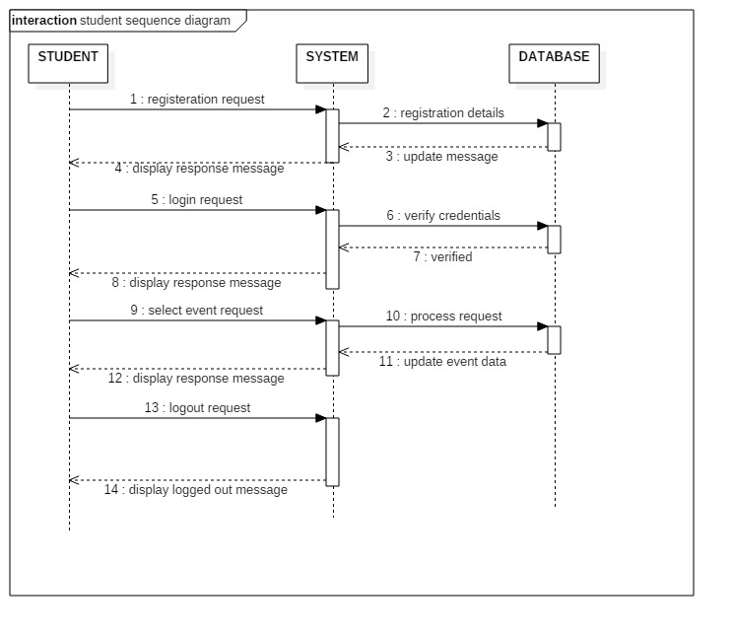
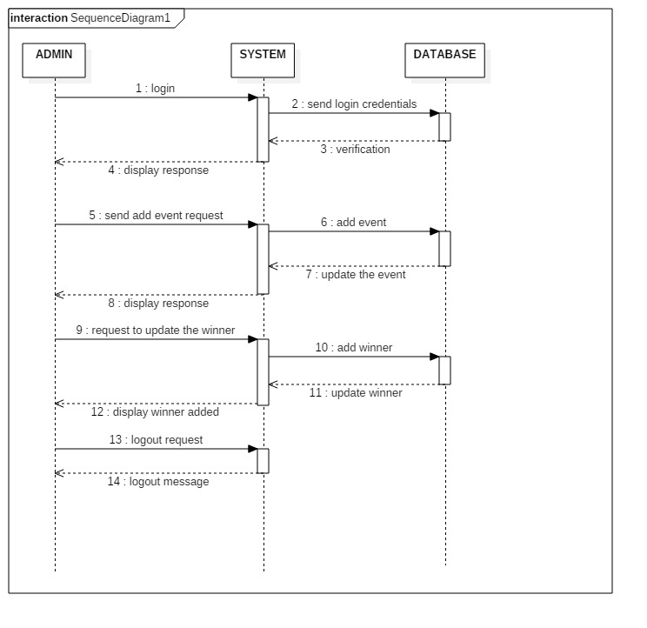

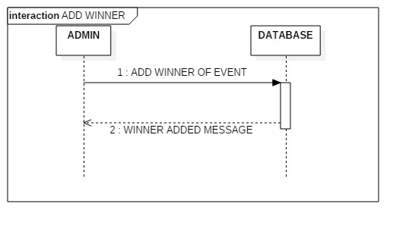

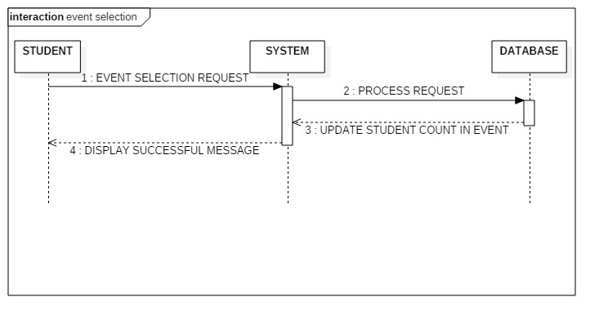
2.1.1.4Activity Diagram

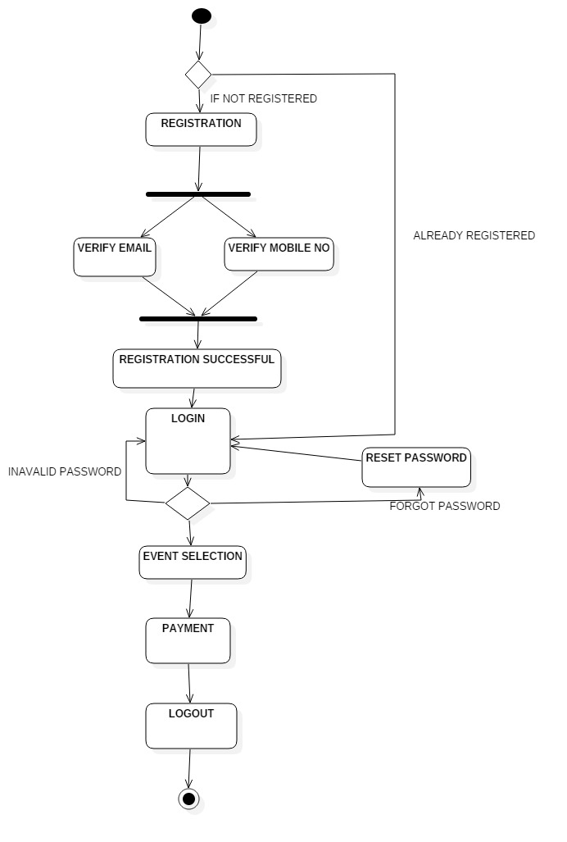

password

Non-Functional Requirements
The non functional requirements include the following:-

2.1.2.1 Performance Requirements
- If unable to process information then display appropriate error message
- The interface should run smoothly(should not lag)
2.1.2.2 Safety and Security Requirements
- The user details should be maintained properly
- Users must be authenticated

User Characteristics
- Admin – has the authority or privileges to add/modify information regarding the event.
- Participants – views the displayed information, registers for events and is able to login.

